**Expense Tracker System: Manage Cash Flow**

**Hassle Free**

A MINI PROJECT REPORT

Submitted By

RAKHUL PRAKASH S B - (220701216)

In partial fulfilment for the award of the degree of

BACHELOR OF ENGINEERING

IN

COMPUTER SCIENCE AND ENGINEERING

RAJALAKSHMI ENGINEERING COLLEGE (AUTONOMOUS) THANDALAM

CHENNAI-602105 2024-2025

**Table of Contents**

1. Introduction
2. Abstract
3. Problem Statement
4. Objectives
5. System Requirements and Scope
6. Software Description and Key Features
7. Programming Languages and Technologies Used
8. Code Implementation
9. Output

10.Results and Analysis

11.Conclusion

**1. Introduction**

The personal finance management sector is increasingly adopting digital solutions to help users manage their finances effectively. Many individuals rely on manual methods, such as spreadsheets or notebooks, to track income and expenses, which can lead to inaccuracies and difficulty in visualizing financial health. As a result, users often struggle to stay on budget, identify spending patterns, and make informed financial decisions. This report discusses an **Expense Tracker System** that enables users to add income and expenses, categorize transactions, and visualize their financial data through interactive graphs. By automating key financial tracking tasks, the system aims to simplify budgeting, improve financial awareness, and empower users to achieve their financial goals.

**2. Abstract**

This **Expense Tracker System** is designed to streamline and modernize personal finance management. The system focuses on three main areas: financial tracking, budget management, and data visualization. Key features include the ability to add and categorize income and expenses for accurate tracking, tools to set and monitor budgets, and an interactive graph dashboard to visualize spending and income trends. By reducing manual effort, improving financial clarity, and providing actionable insights, the Expense Tracker System empowers users to make informed financial decisions and achieve better control over their finances.

**3. Problem Statement**

The traditional approach to personal finance management presents several challenges, primarily due to outdated manual methods. The main issues identified include:

1. **Manual Tracking**: Relying on notebooks or spreadsheets to track income and expenses is inefficient and prone to errors. This can result in incomplete records, difficulty in identifying spending patterns, and limited financial clarity.
2. **Lack of Insights**: Without a system to categorize transactions and generate reports, users miss opportunities to analyze their financial habits. This lack of insight prevents them from making informed decisions and optimizing their budgets effectively.
3. **Limited Visualization**: Manual methods fail to provide a clear, visual representation of financial data, such as income-expense trends or spending categories. This makes it harder for users to understand their financial health and plan for future goals.

These challenges highlight the need for an automated and user-friendly solution to manage personal finances efficiently.

**4. Objectives**

The Expense Tracker System aims to meet the following objectives:

* **Simplify Financial Tracking**: Provide an intuitive platform for users to log income and expenses easily, reducing the reliance on manual methods and minimizing errors.
* **Visualize Financial Data**: Offer interactive graphs and charts to help users understand income-expense trends and identify spending patterns at a glance.
* **Promote Better Budgeting**: Enable users to set, monitor, and adjust budgets, encouraging better financial discipline and goal setting.
* **Provide Actionable Insights**: Generate categorized reports and insights to empower users with the information needed to make informed financial decisions and optimize their financial management.

**5. System Requirements and Scope**

**Functional Requirements**

1. **Transaction Management**: Allow users to add, edit, and delete income and expense entries with categories, descriptions, and timestamps.
2. **Budget Tracking**: Enable users to set budgets for different categories and track their progress against these budgets.
3. **Graphical Visualization**: Provide interactive graphs and charts to visualize income-expense trends and category-wise spending.
4. **Reporting System**: Generate categorized financial reports to help users analyze their spending patterns and financial health.

**Non-Functional Requirements**

1. **Performance**: The system should handle multiple users simultaneously and provide quick responses, even with a large volume of financial data.
2. **Security**: Ensure user data, such as transaction details and budgets, is encrypted and compliant with data protection standards.
3. **Usability**: Offer a simple, intuitive interface for users to easily navigate and interact with the system across devices.

**Scope**

The **Expense Tracker System** focuses on core functionalities such as tracking income and expenses, budget management, data visualization, and generating reports. It does not include advanced features like investment tracking, tax calculation, or integration with accounting software.

**6. Software Description and Key Features**

The **Expense Tracker System** includes various features to address user needs and enhance financial management:

* **Transaction Management**: Users can log income and expenses through a web interface or mobile app. The feature supports categorization, descriptions, and timestamps, ensuring comprehensive record-keeping.
* **Interactive Visualization**: A dynamic dashboard displays financial trends through graphs and charts, enabling users to track income, expenses, and category-wise spending visually.
* **Budget Management**: Users can set budgets for different categories, receive alerts for overspending, and monitor progress to maintain financial discipline.
* **Insightful Reports**: The system generates detailed financial reports, helping users analyze spending patterns and identify areas for improvement.

**7. Programming Languages and Technologies Used**

* **Frontend:** React and Bootstrap are used to create responsive, user-friendly interfaces and dynamic content rendering.
* **Backend:** Node.js is implemented to manage server-side operations, data processing, and application logic.
* **Database:** MongoDB is used for efficient data storage, supporting records such as income, expenses, and budgets.
* **APIs and Libraries:** Third-party libraries are integrated for data visualization, authentication, and other enhanced functionalities.

1. **OUTPUT**

**UI/UX OF THE PROJECT**

**Incomes Page:**

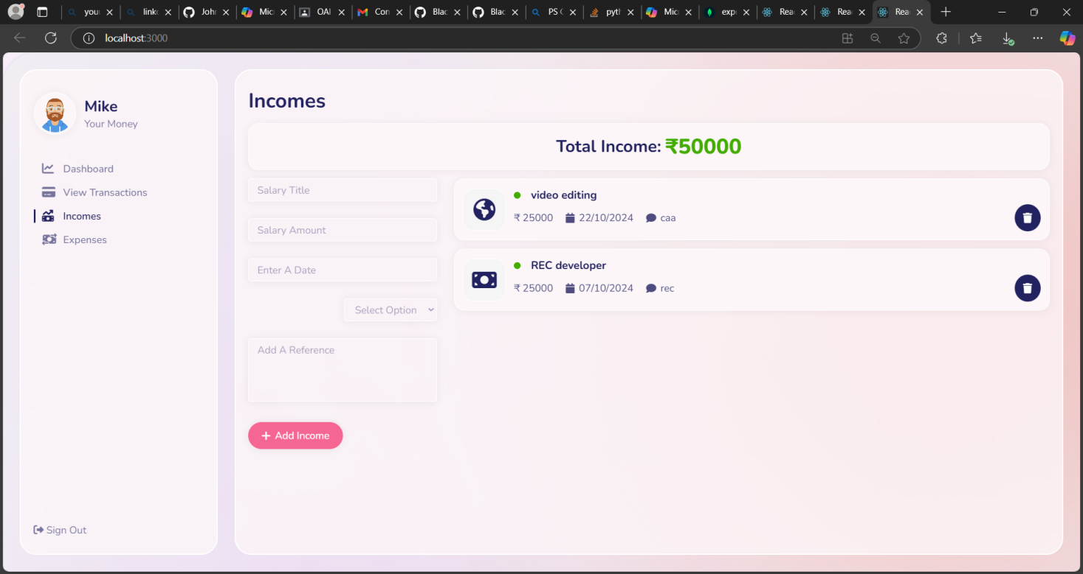

**Dashboard Page:**

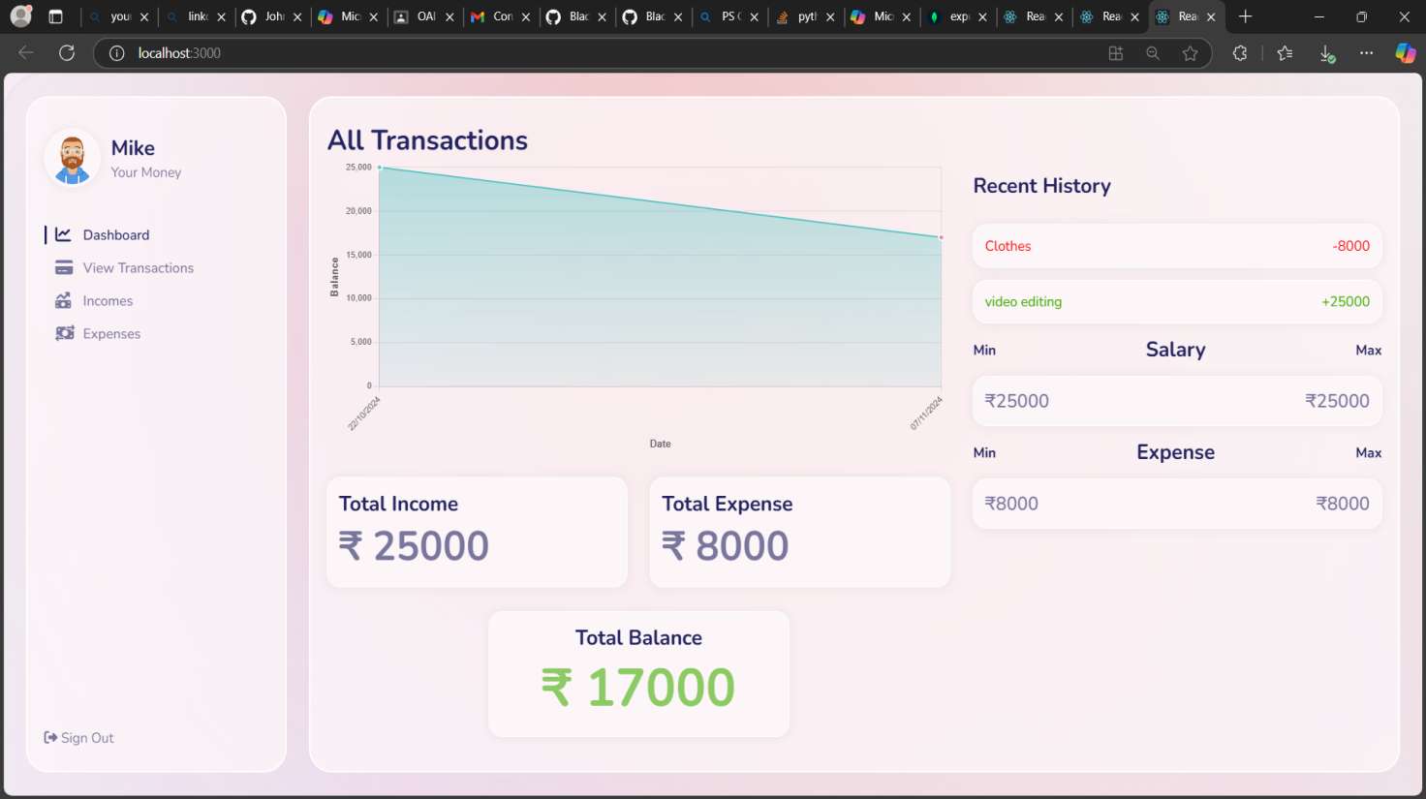

**Expenses Page:**

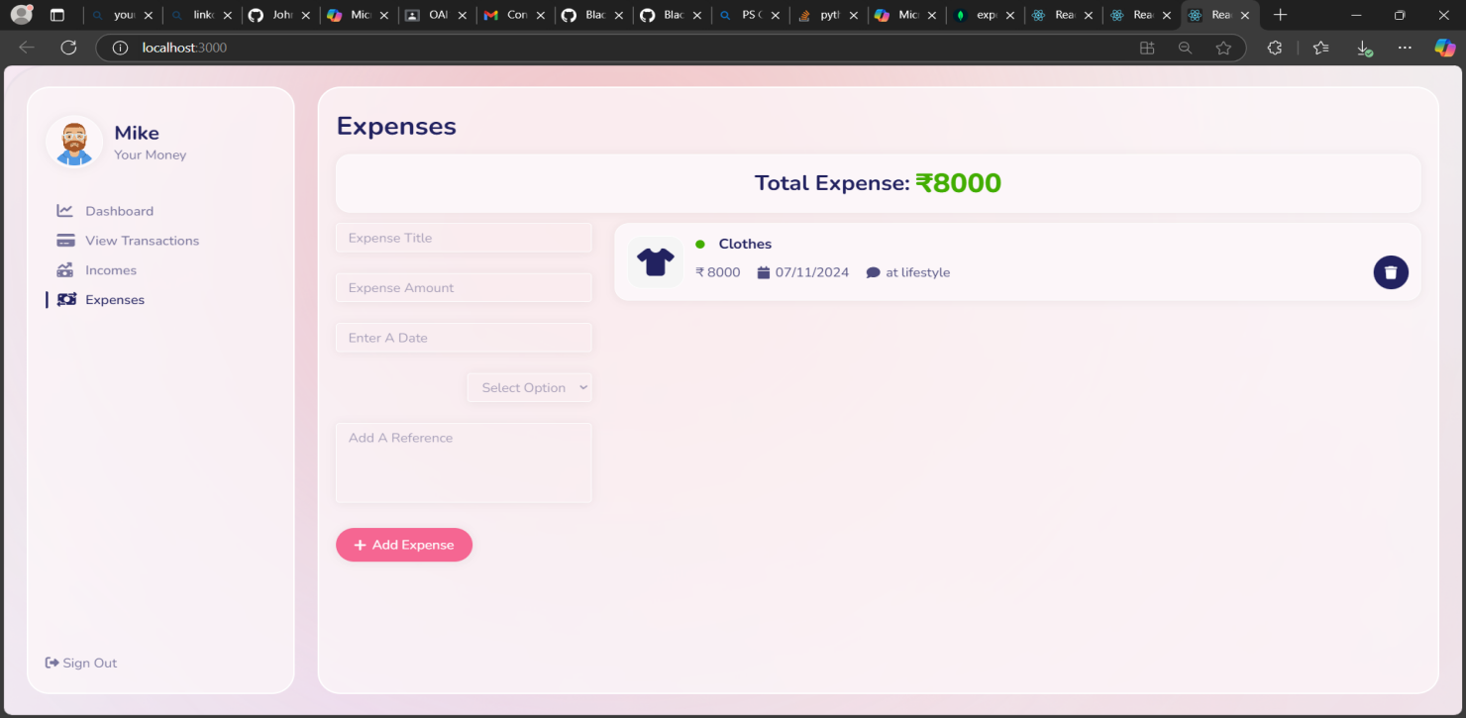

**View Transactions Page:**

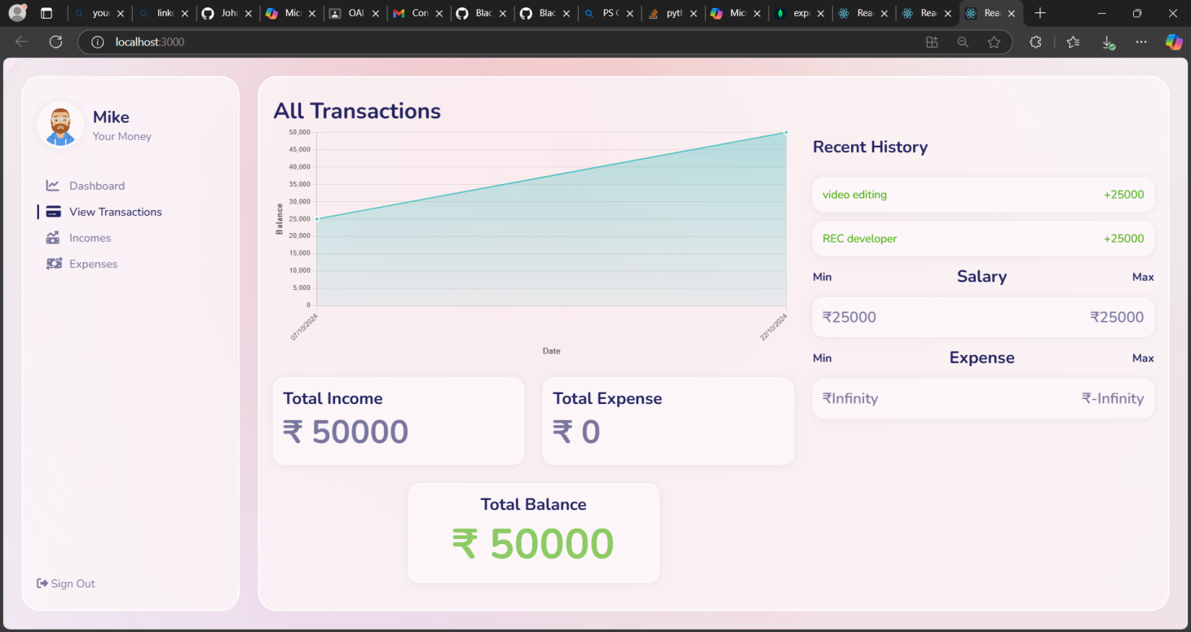

**DATABASE MONGODB**

**Incomes Collection:**

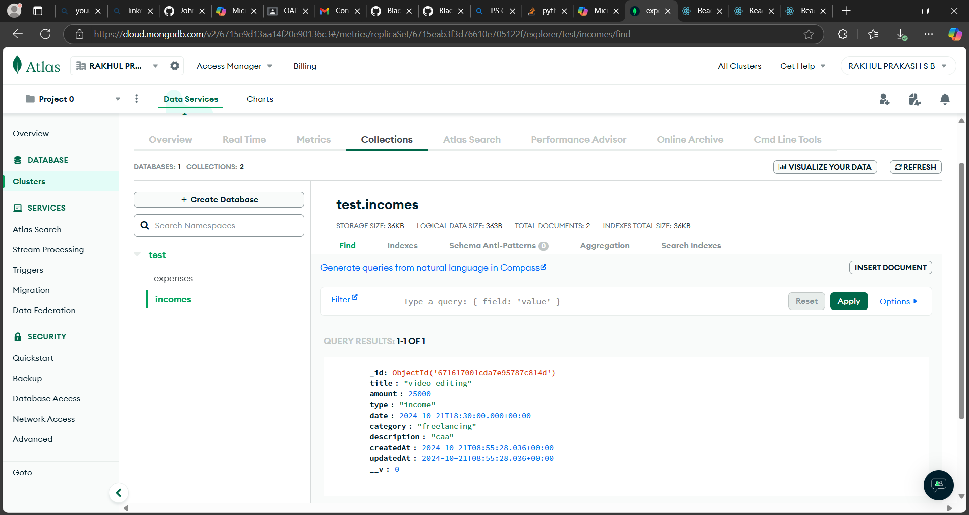

**Expenses Collection:**

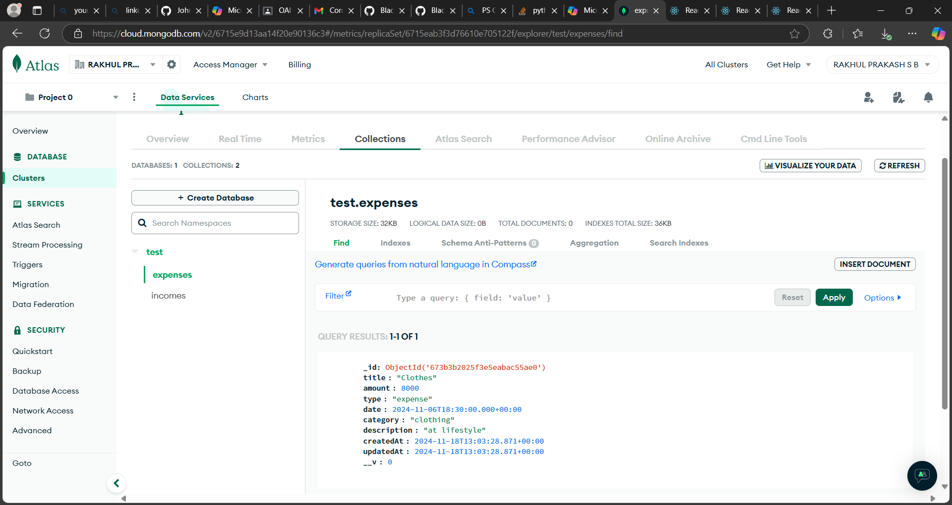

**9. Results and Analysis**

The implementation of the **Expense Tracker System** has demonstrated significant benefits in improving personal finance management. Key outcomes include:

* **Enhanced Financial Awareness**: The ability to track income and expenses categorically has simplified financial monitoring and reduced errors compared to manual methods.
* **Improved User Experience**: Users have reported appreciating the interactive graphs and intuitive interface, which make it easier to visualize and understand financial trends.
* **Actionable Insights**: The reporting and analytics features enable users to identify spending patterns, manage budgets effectively, and make informed financial decisions.

**10. Conclusion**

The **Expense Tracker System** effectively addresses common challenges in personal finance management by simplifying income and expense tracking, offering budget management tools, and visualizing financial trends. By providing detailed reports and interactive graphs, the system enhances financial clarity and decision-making.This project showcases the potential of technology to empower individuals with better financial control, making money management more efficient, insightful, and user-friendly.